

Gold Digger: a searching behavior game

Gabriele Giordano Maria Rossi

School of Computing Science

Sir Alwyn Williams Building

University of Glasgow

G12 8RZ

A dissertation presented in part fulfillment of the requirements of the Degree of Master of Science at the University of Glasgow

<Date of submission placed here>

**Abstract**

<Abstract goes here…>

Education Use Consent

I hereby give my permission for this project to be shown to other University of Glasgow students and to be distributed in an electronic form.

<**Please note that you are under no obligation to sign this declaration, but doing so would help future students.>**

Name: Signature:

Acknowledgements

<Acknowledgements go here>

Contents

Chapter 1 Introduction 1

1.1 Overview 1

1.1.1 Problem Statement 1

Chapter 2 Survey 2

2.1 Background Theories 2

2.1.1 Optimal Foraging Theory 2

2.1.2 Information Foraging Theory 2

2.2 Previous Studies 2

2.2.1 Searching Behavior 2

2.2.2 Related Games 2

Chapter 3 Design 2

3.1 Site Map 2

3.1.1 World Map 2

3.1.2 Game Screen 2

3.1.3 General Store 2

3.1.4 Leaderboards 2

3.1.5 Tutorial 2

3.1.6 Achievements 2

3.1.7 About Page 2

3.2 Walkthrough 2

3.3 System Architecture 2

3.4 ER Model 2

Chapter 4 Implementation 2

4.1 Development Methods 2

4.2 Heuristic Evaluation 2

4.3 Testing 3

4.3.1 Unit Testing 3

4.3.2 Live Testing 3

4.4 Technologies 3

4.4.1 Django 3

4.4.2 Python 3

4.4.3 HTML5 3

4.4.4 CSS3 3

4.4.5 Twitter Bootstrap 3

4.4.6 Javascript and JQuery 3

4.5 AJAX 4

4.6 Code Overview 4

4.7 Reusability 4

4.8 Implementation issues 4

Chapter 5 Results and Data 4

5.1 Data Logged 4

5.2 Data Analysis 4

5.3 Results 4

Chapter 6 Summary and conclusions 4

6.1 4

6.2 Future work 4

6.3 4

6.4 References 5

Appendix A <Name of appendix> 1

Appendix B <Another appendix> 2

# Introduction

Introduce the project.

<This is style Normal. We recommend you make use of styles to simplify creating a well-formatted document. We have used “space before” and “space after” in defining these styles, in order to space the headings and paragraphs appropriately. You should never need to enter a blank line.>

## Overview

Please note your dissertation need not follow the included section headings – this is only a suggested structure. Also add subsections etc. as required.

### Problem Statement

Try to avoid this too much, but it’s here if you need it.

# Survey

## Background Theories

### Optimal Foraging Theory

### Information Foraging Theory

## Previous Studies

### Searching Behavior

### Related Games

# Design

## Site Map

### World Map

### Game Screen

### General Store

### Leaderboards

### Tutorial

### Achievements

### About Page

## Walkthrough

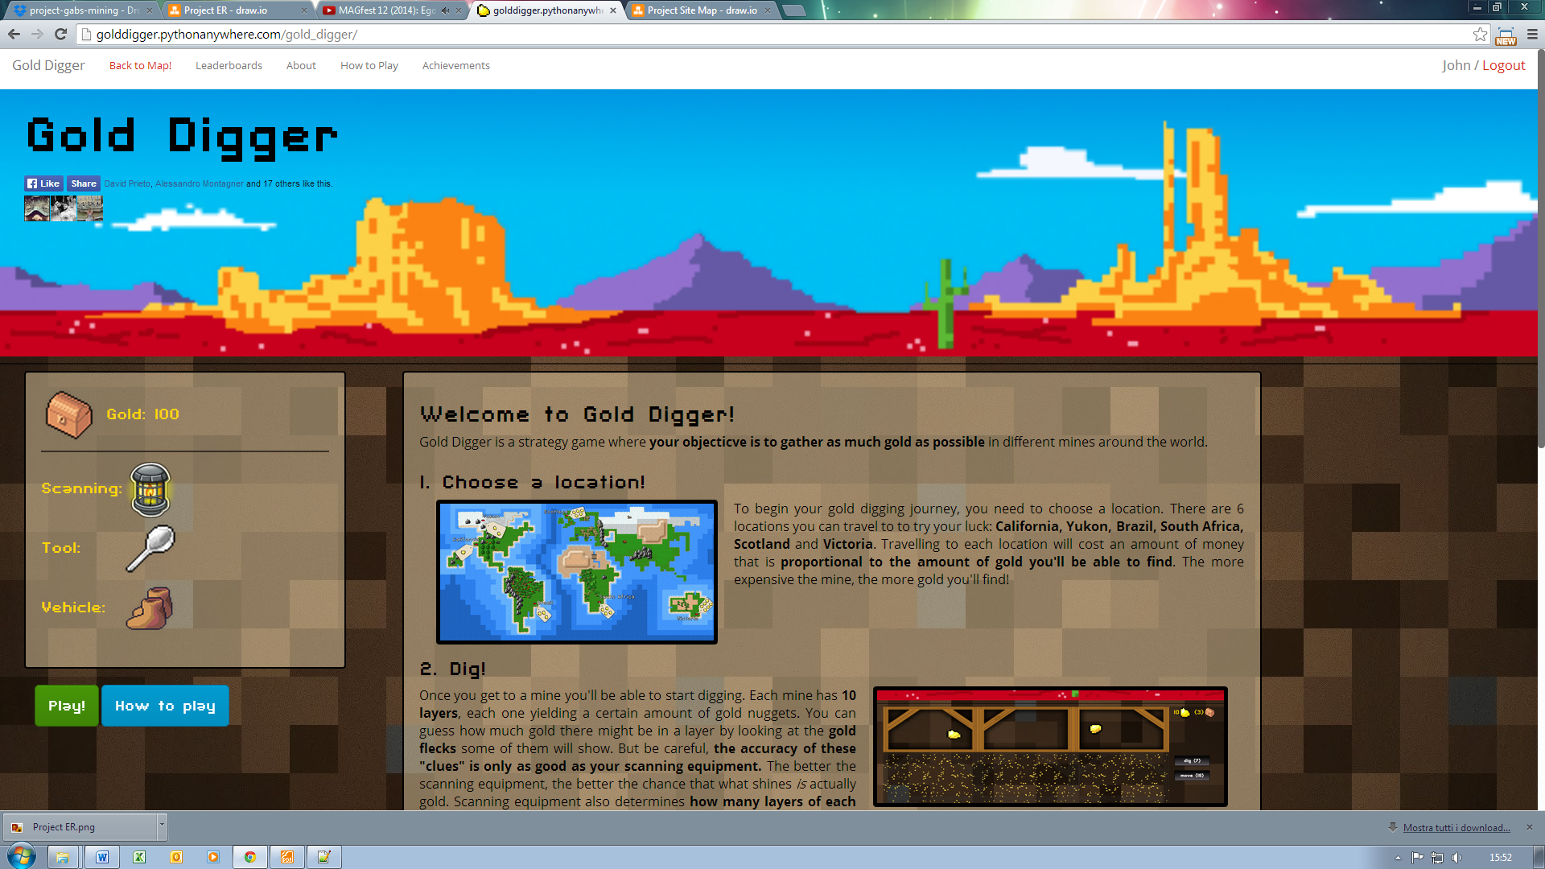

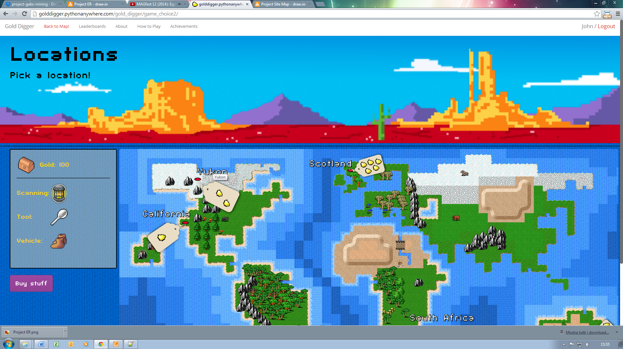

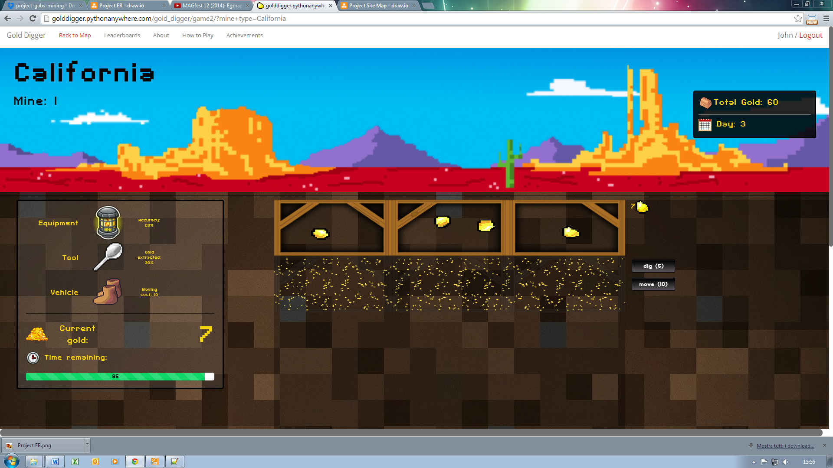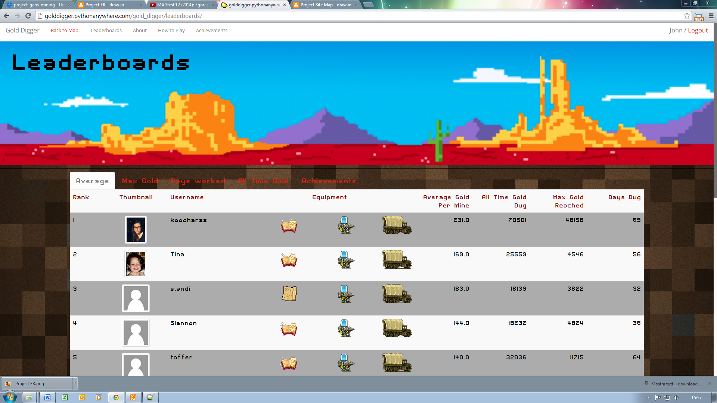

## System Architecture

## ER Model

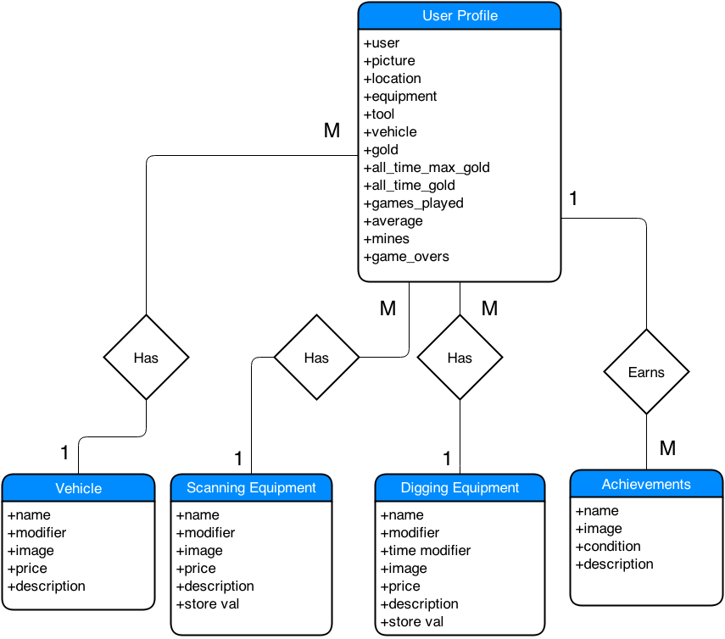

# 

# Implementation

## Development Methods

## Heuristic Evaluation

## Testing

### Unit Testing

### Live Testing

## Technologies

### Django

### Python

### HTML5

### CSS3

* **Animate.css**

### Twitter Bootstrap

### Javascript and JQuery

* **Trip.js**
* **AnimateNumbers.js**
* **Resize.js**

## AJAX

## Code Overview

## Reusability

## Implementation issues

# Deployment

# Results and Data

## Data Logged

## Data Analysis

## Results

# Summary and conclusions

## Conclusions

## Limitations

## Future work

## Reflection

## References

[1] C. Baier and J.-P. Katoen. *Principles of Model Checking*. MIT Press, 2008.

###### <Name of appendix>

<Use Heading 6 for the Appendix heading>

###### <Another appendix>